Open HEA Software User Guide:

Part II: MiniProject

# Background

## The Integrated Database for African Policymakers(IDAPs)

The Household Economy Approach (HEA) is a proven methodology and data set for describing how a rural population gets access to the food they need – a Livelihoods dataset. IDAPs seeks to integrate livelihoods data with climate, hydrology, weather and crop data to provide an extended analytic dataset that will enable policymakers and researchers to better understand the vulnerabilities and risks that face such rural populations. For more information on HEA see the [Evidence for Development (EfD) website](http://www.efd.org/our-work/methods/).

#### The first phase of the project will deliver a globally-accessible and sharable database for collecting and analysing the HEA dataset that is at the heart of IDAPs.

## Software Overview

The Open Household Economy Approach (Open HEA or OHEA) component of IDAPs is an application that manages the data collected during an HEA baseline study. The software allows users to capture the results of HEA Community interviews to configure their study and then generates template spreadsheets in MS Excel format to capture the data collected in Wealth Group interviews. IDAPs eliminates the need for additional paper records e.g. maps. It also stores geographical coordinates and other project site details e.g. district, sub district, community, date of interview etc.

The modules of this program include Project, Community and Wealth Group categories that record information about the area of study e.g. assets and sources of income and types within a community and different wealth group. The application is designed to provide reports, charts and other information used by Government, NGOs and others that understand how communities in different social and economic circumstances get the food and cash they need; their assets; the opportunities open to them; the constraints they face; and the options open to them at times of crisis. The OHEA component of IDAPs will, in future phases of the project, be integrated with other components that will incorporate climate change information which is not currently included in socio-economy assessment tools.

All acronyms and abbreviations used in this document are introduced in full before being used. However, for completeness, they are summarised in Appendix A – Acronyms and Abbreviations. Because this software is intended for use by trained HEA practitioners, the terminology and concepts of HEA and Livelihoods measurement are used freely, without explanation. Full explanations are available at the EfD website linked above.

## Prior Learning

This tutorial follows on from the first part of the OHEA User Documentation – The OHEA Walkthrough. Before following this tutorial, you should follow that tutorial because it shows you how OHEA works, including how to register for a log-in to the IDAPs platform, and gets you used to the software interaction model that it follows.

This Tutorial assumes some familiarity with OHEA which without that tutorial you will not have.

## Logging in

We first start by clicking on the website <http://idaps.walker.ac.uk:8080/EFD_v2/m/SignIn>. This will give a view that requires to enter the User name and Password to access the OHEA Software

In the “Organization” drop-down, select “OHEA_Training”.

Enter your user name and Password then click the “Sign in” button

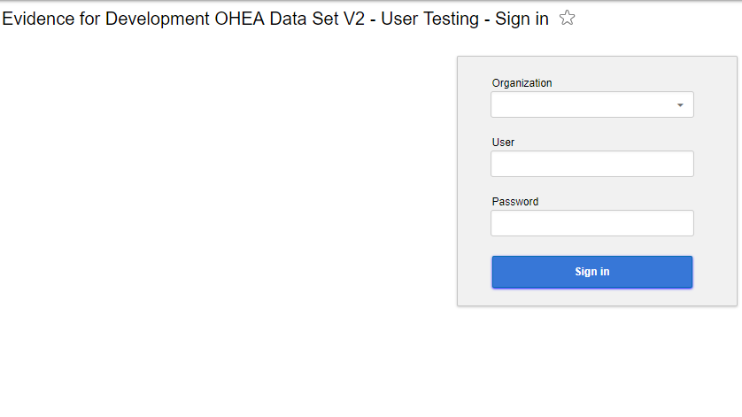

When you log in you normally see the screen you were looking at before you last logged out. The first time you log in you will see a page will appear with “Start” and “First steps” on the Menu.

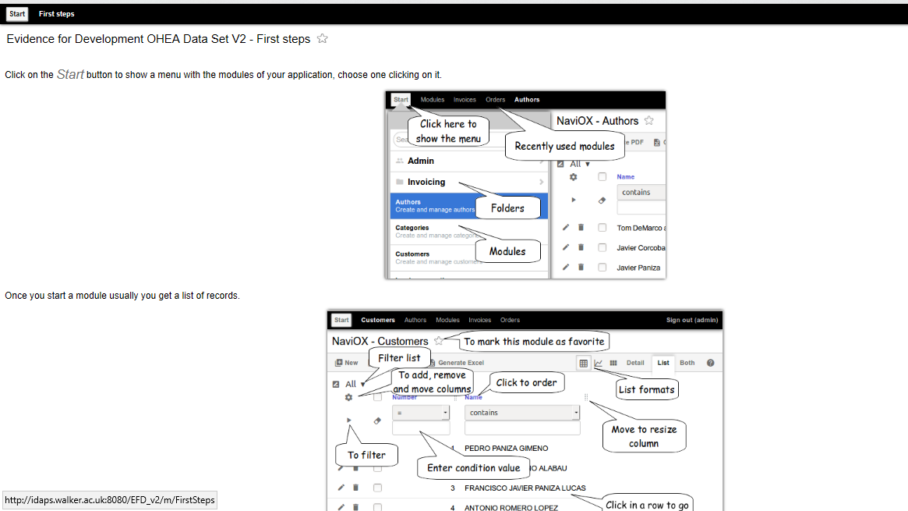

Click **Start**

When you Click on the Start button a menu with the modules will appear. You can search the module of your application that you want to use (Community, Project, Country etc.) in the “Search Modules” search box.

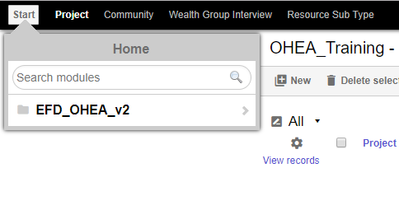

# Using the Software – From creating a Project to generating an Interview template

In the Walkthrough Tutorial you only looked at data in an existing dataset; now let’s create one from scratch.

### Creating the project

The menu bar on OHEA lists recently used modules, so if you’ve just done the Walkthrough Tutorial, “Project” will be there.

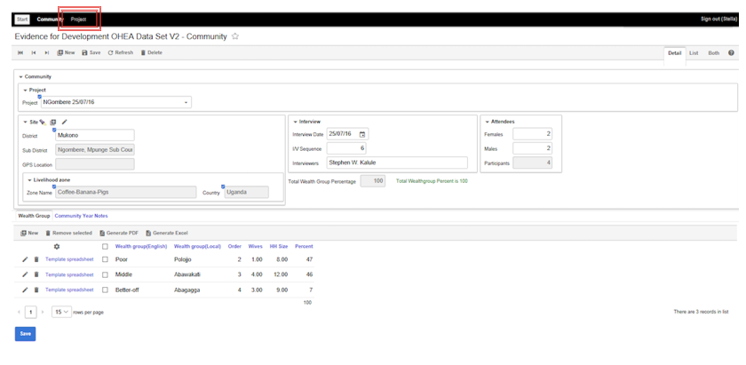If “Project” is visible in the Menu bar:

Click on **Project**

If you don’t see “Project” in the menu bar, and this goes for using any module not in the menu bar:

click on the **Start** button at the left of the menu bar.

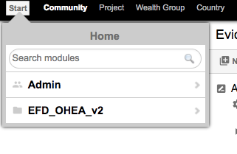

After you click “Start” the “Search modules” box will appear.

Type “Project” in the search modules box and if you take a pause it will find the “Project" module.

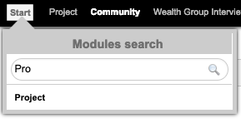

Click on it and it will invoke the Project module.

You’ll see a list of existing projects displayed.

Click the **New** button in the top left, to create a new Project

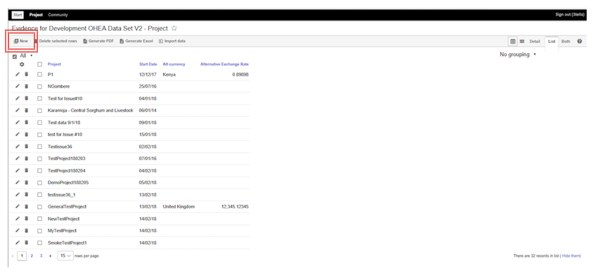

and the Project editor will appear – this is the Detail view.

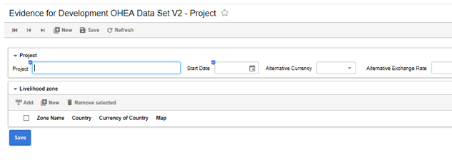

At the top-right ‘tabs’ labelled “Details”, “List” and “Both” are displayed. For now, we want to create a “Project” so “Details” is the active tab.

To create a Project:

Enter the name of your project in the Project field and select the start date in the Start Date calendar picker. You’ll notice those fields are highlighted with a small blue icon to indicate that it is mandatory to enter values in these fields.

Choose a suitable name for your project, for example “MyTestProject”, and any date.

You’ll also want to define the Livelihood Zone (a geographical area) the Project will survey, but first enter those Project details

Then click **Save**.

### Adding a Livelihood Zone

Click **New** on the Livelihood Zone menu bar to invoke the LZ editor

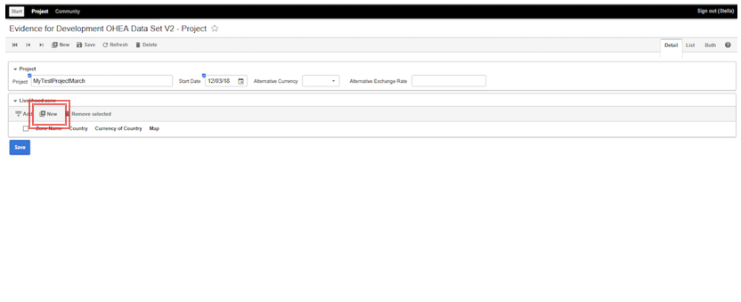

Enter a name and select a country (note the mandatory field indicators again).

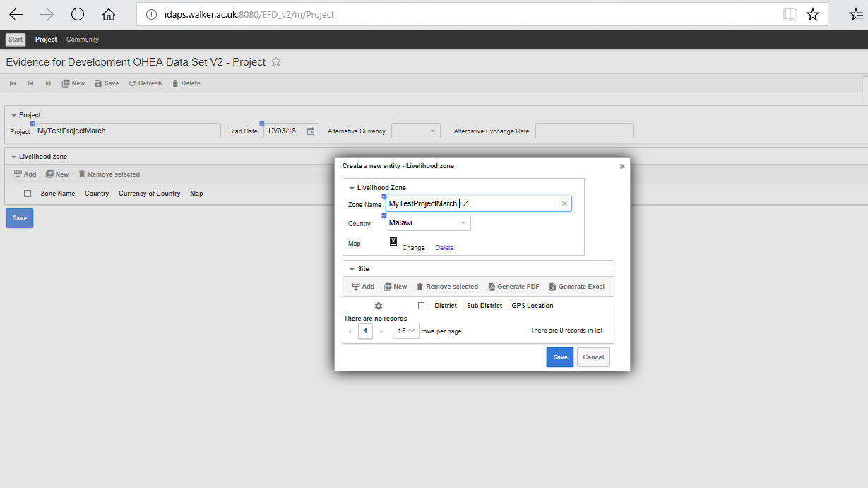

Then click **Save**.

You have now created a new project. You could also have uploaded a graphic image of the LZ map, but ignore that for the moment.

Next step is to identify the villages in the LZ that will be surveyed.

### Adding Communities to a Project

In an HEA study, you identify a number of Sites (typically villages) where you will survey. At each Site you first interview a group of influencers and senior people who understand the Community that lives in that village. The data collected in the Community interview is what you will enter here. In an HEA study there will be several Communities, perhaps ten or more, so to exercise the software we’ll create one in full detail and then an overview of some others. Communities are typically divided into different Wealth Groups (WGs) each of which comprises of people who broadly live the same way (the same sort of access to Land, growing the same Crops, gaining Employment in the same sorts of work and so on). Our HEA study team will interview representatives of each WG in a Community to get all the details of how they get access to food and money. The data from the Community interview helps the interviewers structure their interview and know what to expect when they meet representatives of each WG.

Before creating a WG, let’s first create a community

Invoke the ”Community” module, from the Menu bar, or use the “Search modules” capability as you did earlier, if it is not on the Menu bar.

If the List view is active, you will see a list of all the Communities in all the Projects.

Click **New** in the top left corner of the screen.

You’ll see the Communities edit view, blank ready for you to insert your new Community

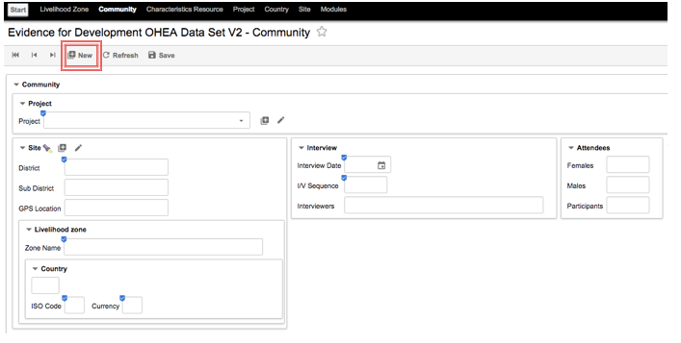

Click the Project field drop-down and select your Project (the project you just created) from the list displayed.

Hint: If there is a long list in the drop-down, start typing the name of your project and the drop-down list will dynamically shorten to just those that match.

You will see a number of sections you will need to define for your Community (Site, Interview, Interviewees, Livelihood Zone).

The first is the “Site” – the village where your Community lives.

If you did not create the project, the Site might be already defined. To search for any pre-existing Sites:

Click the torch/flashlight symbol in the top left of the Site box.

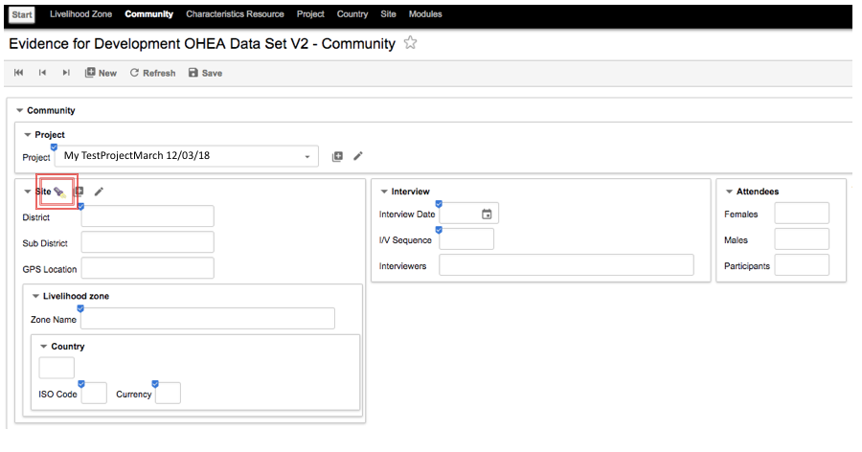You will see there are no Sites defined in the LZ.

Dismiss the null list by clicking **Cancel**

We can now concentrate on creating the Community:

Click the **+** button, next to the torch/flashlight icon, to add a new Site.

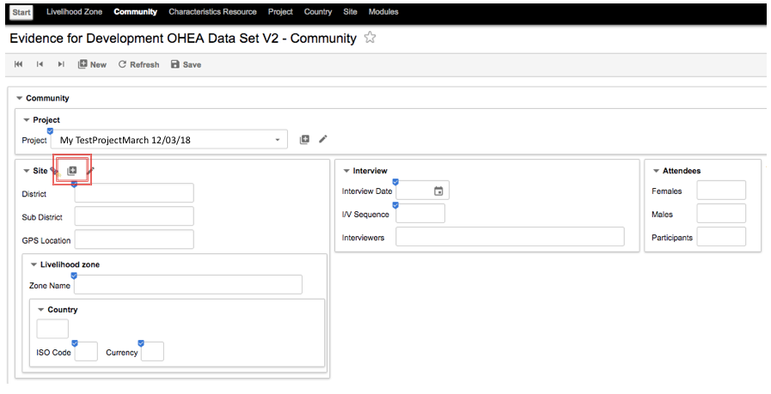When you click **+** you will see a pop-up entitled “Add-Site”.

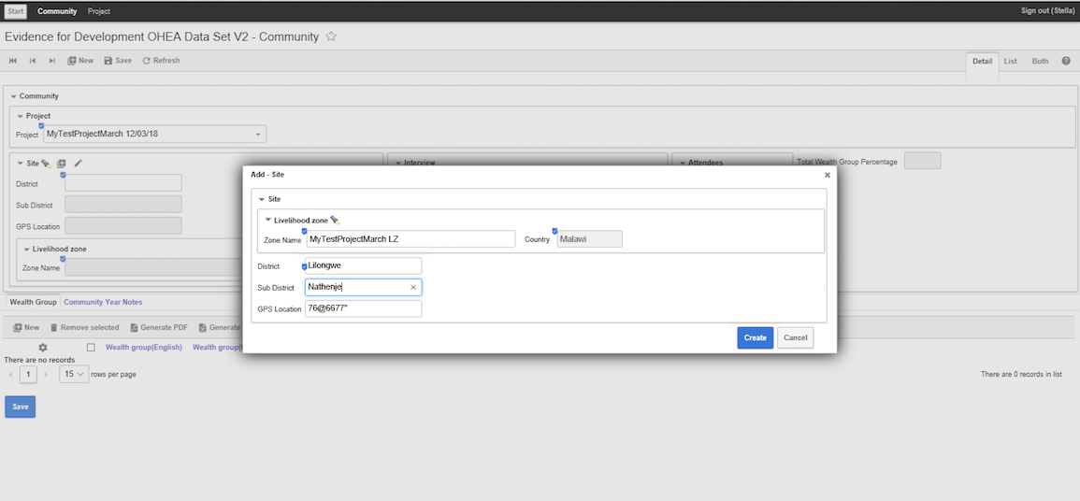

Under the Site icon you will see “Livelihood zone” and Filtered Search button

Click the Livelihoods **Filtered search** (torch/flashlight) to select the LZ.

(Note there should only be one - the one you entered)

Click the one you entered previously.)

You will see automatically the country name will appear.

Enter names for the District and Sub-District, from Table 1 below.

Click **Create** to complete definition of the Site

When you completed the District & Sub-District, you define the Village where your Community lives. You see the details of the Project and Livelihood Zone filled in, to confirm and give context.

You are now ready to enter the other data for the Community record;

Enter the rest of the data for the Interview, also from Table 1 below.

You can enter GPS Coordinates or leave it blank.

|  |  |
| --- | --- |
| I/V Sequence | 1 |
| Interview Date | 22/7/2016 |
| District | Mukono |
| Date | 22/07/2016 |
| Village/Sub District | Bugoye/Ntenjeru |
| Interviewers | Hosea, John |
| Men: | 7 |
| Women | 2 |
| Number of participants | *(This will be calculated)* |

Table 1: Interview Data

Hint: The participant numbers you are entering here relate to the participants in the Community interview. When you record the details of Wealth Group interview in the spreadsheet you will enter the participant numbers for that interview

Note that the Number of participants is calculated automatically from the total of Men and Women.

Click the **Save** button in the module menu bar

You’ll also see the field Total Wealthgroup Percent is 0 and there is an amber warning message:

“Total Wealthgroup Percent is less than 100”

Ignore it for now; it will automatically add to 100 after you have entered all the WG properties.

You have now created the Community.

### Defining the Wealth Groups in a Community

If you return the display to the List view, you may not be able to see the Community you just entered in the mass of others. This is often the case when you are searching for a Community because other users may have created projects. You need to filter the list.

You are really only ever interested in the Communities in your Project; we can filter this view to just that. Alternatively, you can sort the communities into alphabetic order so that, even if you have to scroll through them, you will easily be able to find the one you want.

To sort the communities list alphabetically by Project:

Click on the “Project” column title as below:

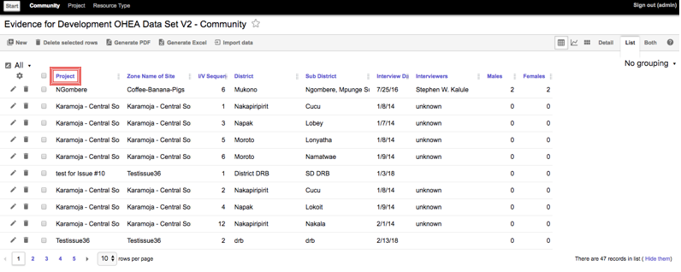

To filter the communities list:

Click the **Customize list** control – a little cog wheel below the “All” button.

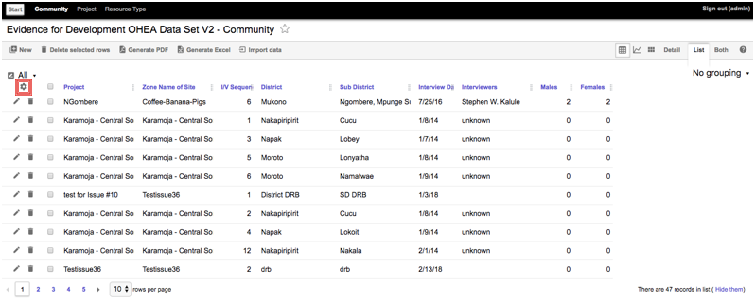

You’ll now see the customization controls. There are many. What you want to do is to filter the list.

Click the **Filter** control – a little funnel, next to the cog wheel.

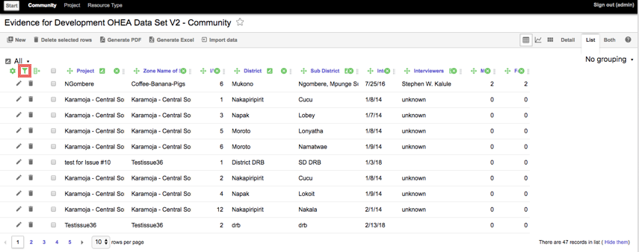

At the top of the Community list you’ll now see a row of blank dropdown fields that allow you to Filter the List of Communities. You have the same capability on all Modules.

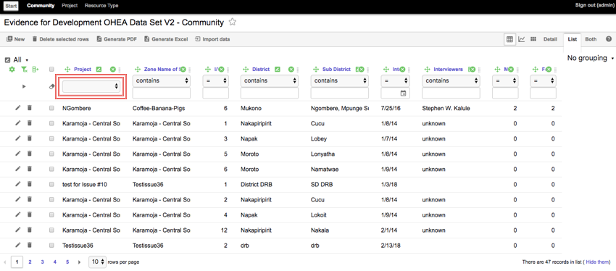

Click in the Project **filter field** and pick your project from the list.

Hint: if you start typing the name of your project when you see the list, it will immediately filter; this will make it easy to find your project in a potentially long list.

You’ll see the Community record you just created.

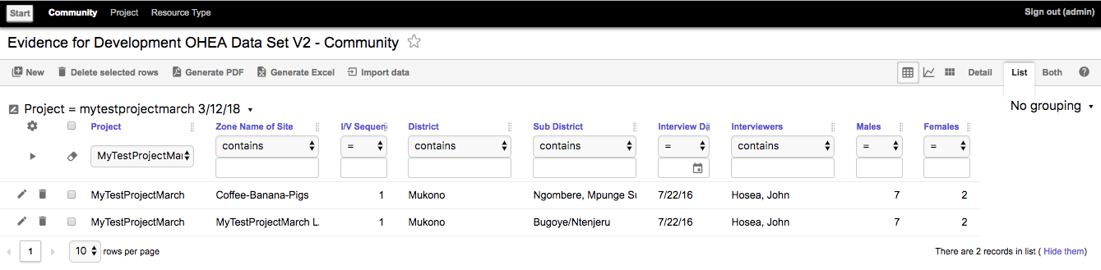

Click the name of your Community, to add the Wealth Groups to it.

At the bottom of the Communities module display you’ll see a block with 2 tabs, “Wealth Group” and “Community Year Notes”. The default tab is “Wealth Group” so you should see this view there”

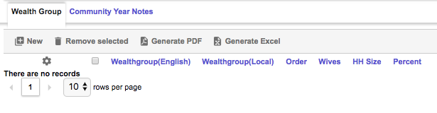

If you see this:

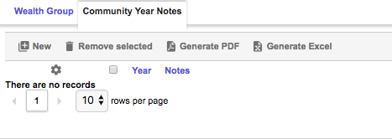

Click the **Wealth Group** tab name to bring the focus to it.

Click **New** to invoke the Wealth Group editor.

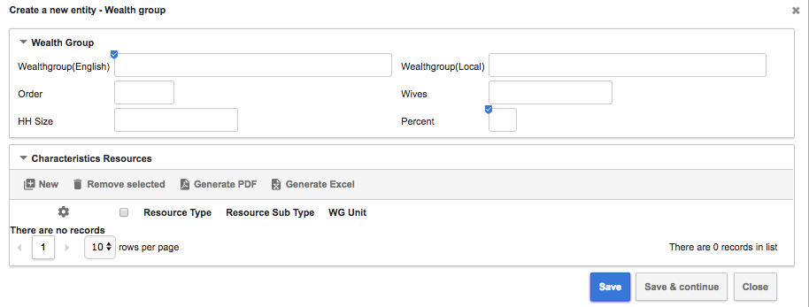

Enter the data in Table 2, below to define three Wealth Groups

Between each Wealth Group, click **Save and Continue**.

After the final, third record, Click **Save**

|  |  |  |  |
| --- | --- | --- | --- |
|  | **WG 1** | **WG 2** | **WG 3** |
| Wealth group name (English) | Poor | Middle | Better Off |
| Wealth group name (local language) | Lucholo | Mugaga | Befikera |
| WG order, poorest (1) to richest | 1 | 2 | 3 |
| No. wives per husband (if polygamous society) | 1 | 2 | 3 |
| Household Size | 5 | 6 | 9 |
| % of households in each wealth group | 47 | 48 | 5 |

Table 2: Wealth Groups

The Wealth Group edit popup will disappear revealing the Community module, with the Wealth Group Data you have entered:

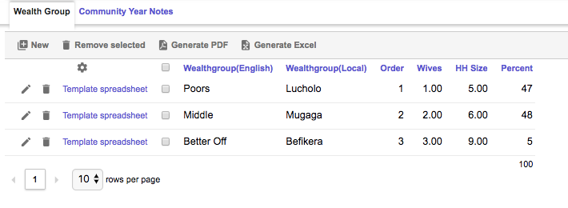

The Total Wealth Group Percentage is now 100; you may have noticed the warning message that displayed before all the Wealth Groups were defined is now replaced by a green message confirming the percentages of households in each Wealth Group add up to 100.

### Entering the Wealth Groups’ Characteristic Resources

The Community interview also where the survey team finds out what to expect of each Wealth Group. For example, what Assets (tools, etc.) might we expect them to have? What employment? What Crops and so on? Before we can generate a template spreadsheet for a Wealth Group interview we need to enter that data.

In the Community module click on the Poor Wealth Group name.

In the Wealth Group edit popup, click **New** in the Characteristic Resources panel in the lower half of the window.

That will pop up the Characteristic Resources editor.

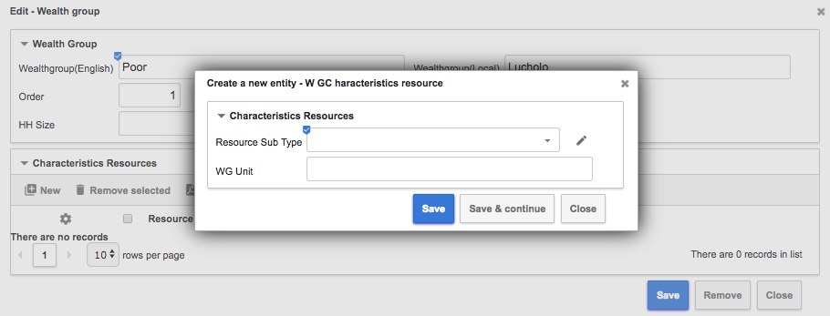

Characteristic Resources is the name given to the broad range of Land, Livestock, Other Assets, Employment and Crops that we might expect a Wealth Group to have access to. And we want to make sure they all turn up in the template spreadsheet to remind the interviewers to ask about all these resources – although they will almost certainly encounter others as well that they will have to add in.

For each resource we need to know the type (Land, Livestock, Crops, etc.) and the actual resource (Goats, Bean, etc.). Table 3, below shows the Land & Livestock we might expect each wealth Group to have.

To enter the Characteristic Resources:

Click in the Resource Sub Type dropdown

The list is way too long to search through for the resource, so we need to search it.

Start to type “Goats”, the first resource of the “Poor” Wealth Group

The list will immediately be truncated to entries that contain the string as you type.

Select “Livestock Goats” and then enter “item” in the units

Note that although we expect, from the data collected in the community interview, that a “Poor” family in this Community would likely have one Goat, we don’t store that quantity. It is enough that the Wealth Group interviewer will be reminded to ask about Goats.

Click **Save & Continue** and enter the other Characteristic Resources of the “Poor” WG.

Then click **Save**

Table 3, below, provides some example Characteristic Resource data for you to enter for each Wealth Group.

|  |  |  |  |  |  |
| --- | --- | --- | --- | --- | --- |
| **Resource Type** | **Resource Sub Type** | **Unit** | **WG1** | **WG2** | **WG3** |
| Land | Upland | Acre | ✓ | ✓ | ✓ |
| Livestock | Goats | Item | ✓ | ✓ | ✓ |
|  | Pigs | Item | ✓ |  | ✓ |
|  | Chicken | Item | ✓ | ✓ | ✓ |
|  | Ducks | Item |  | ✓ | ✓ |
|  | Dairy Cow | Item |  | ✓ |  |
|  | Local Cow | Item |  |  | ✓ |
| Livestock Products | Chicken Eggs | Item | ✓ | ✓ |  |
| Crops | Banana | Kg |  | ✓ | ✓ |
|  | Coffee | Kg |  | ✓ | ✓ |
|  | Maize | Kg |  | ✓ | ✓ |
|  | Beans | Kg |  |  | ✓ |
|  | Cassava | Kg | ✓ | ✓ |  |
|  | Sweet Potato | Kg | ✓ | ✓ |  |
|  | Ground Nuts | Kg |  | ✓ | ✓ |
| Employment | Digging | Day | ✓ |  |  |
|  | Boda Boda | Day |  | ✓ |  |
|  | Government Worker | Month |  | ✓ | ✓ |
|  | Shop Keeper | Month |  | ✓ | ✓ |

Table 3:Characteristic Resources

The wealth group edit popup now shows the Characteristic Resources data we have entered.

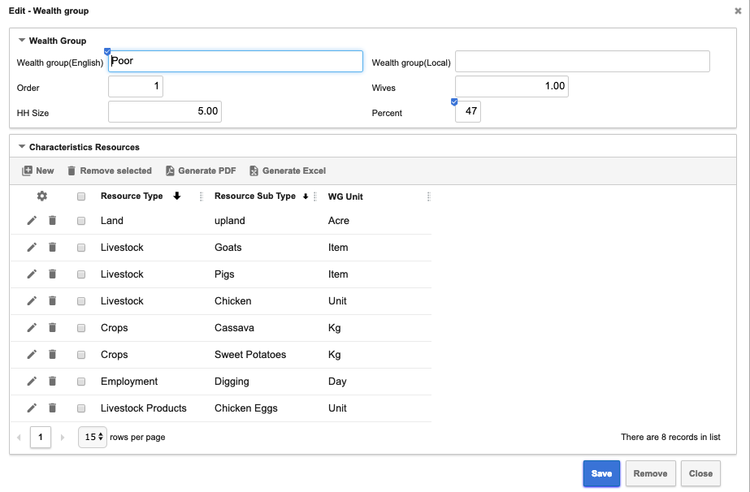

Click **Save** to return to the Community module and the list of Wealth Groups.

Click the “Middle” Wealth Group record **Name** and enter its Characteristic Resources data in the same way.

And then do the same for the “Better Off” Wealth Group.

You have now entered all the data for our Community and you can generate the Wealth Group interview Template Spreadsheets, just as we did in the Guided Tour above.

In a real survey there will be multiple Communities, but they are each defined in a very similar way. One is enough for this exercise.

### Generating a Wealth Group Interview Template Spreadsheet

To generate the spreadsheets for the Wealth Group interviews.

Click on **Template spreadsheet** for the WG you want to generate.

Hint: your generated template spreadsheet will be saved to your default download location (e.g. desktop, downloads folder or other). You can move it elsewhere to edit it, if you wish, but either way, you will need to keep track of the location. That’s where you will upload the completed spreadsheet from later.

### Reviewing the Generated Spreadsheet

Open the generated spreadsheet from wherever it was saved, or you have moved it

On the Interview tab you will see the details of the Wealth group you have entered.

If you click through the Assets – Land, Assets – Livestock, Crops, Livestock Products and Employment tabs, you will see the Characteristic Resources you entered have been generated as stub entries to remind you at the interview to look for these resources. For example, the screenshot below shows the Livestock tab.

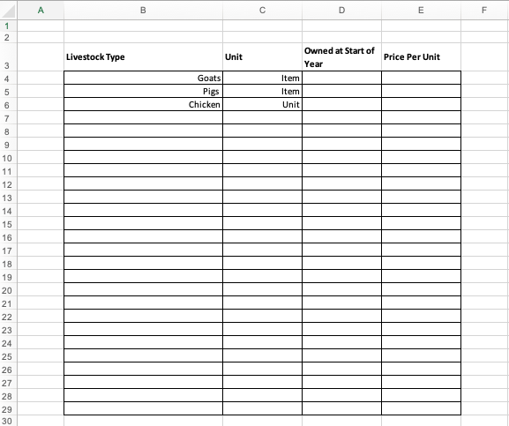

Of course, there is space to enter the other resources you will no doubt encounter in the interview.

That was the final stage of the Guided Tour: Generating the Wealth Group Interview spreadsheets.

## Summary

You’ve now exercised pretty much all the features of the software necessary to create a project, define Communities and Wealth Groups, to enter the Characteristic Resources each Wealth Group might be expected to have access to and to generate the template spreadsheet to collect the results of the Wealth Group Interview.

In this section of the document we’ve tried to provide short explanations of how an HEA survey dataset is assembled – to provide a context for the operation of the software. But this document is by no means a definitive tutorial on HEA, the methodology and fieldwork best practice.

It is simply an annotated guide to using the OHEA software.

In the next section we will see how the results of an interview are uploaded into the software and analysed.

# Wealth Group Interview Spreadsheet Processing

## Introduction and overview

The Wealth Group Interview is the critical data gathering part of an HEA Baseline study. It will define the livelihoods of each of the identifiable Wealth Groups in a Community.

In order to make data loading from the interview process as easy as possible, a spreadsheet template is generated. The Community Interview captures data about the characteristic resources of each wealth group. This will include, for example, the expectation that a hpousehold in the Middle Wealth Group might be expected to have 10 Goats. The generated spreadsheet for the Middle Wealth Group would then include an entry already partly populated in the Assets – Livestock tab for “Goats”.

### Community interview data

The following types of resources may be captured in the Community interview as likely resources of one or more WG and subsequently included in the templates generated for the WG interviews, in the tabs as indicated.

|  |  |
| --- | --- |
| **Resource** **Type** | **Spreadsheet Tab** |
| Land | Assets - Land Type table |
| Livestock | Assets – Livestock Table |
| Other tradeable goods | Assets – Other Tradable |
| Food stocks | Assets – Food Stocks |
| Trees | Assets – Trees |
| Cash Savings | Assets – Cash |
| Crops | Crops |
| Livestock sales | Livestock Sales |
| Livestock products | Livestock Products |
| Employment | Employment |
| Transfers | Transfers |
| Wild foods | Wild Foods |
| Food purchases | Food Purchases |
| Non-food purchases | Non-Food Purchases |

The last step of recording the Community interview data, as described above was to generate the template spreadsheets for the WG interviews. As well as creating the spreadsheet and downloading it for the interviewer, the software also creates a blank Wealth Group Interview record in the database ready for the completed interview spreadsheet to be uploaded into. We will cover uploading later. First, we need to collect and record the WG data.

### The wealth group interview

Wealth group interviews are normally conducted using a template form for the interviewer’s notes. Some practitioners prefer to use their own note conventions. Whichever way you work you need to enter the data collected into the template spreadsheet you have generated to load it into your project in the OHEA database.

Often, not all the expected or typical resources that were identified in the Community interview and included in the template will actually be confirmed by the WG Interview participants. These should be deleted by the interviewer. And frequently other sources will be identified by interviewees; these should be added into the WG interview spreadsheet.

The spreadsheet contains some validation and lists-of-values to help the interviewer transcribe their notes more quickly and more accurately, but the major validation happens when the data has been uploaded. A common example is a typo in the name of a crop. That will be caught when the uploaded spreadsheet is validated against the list of crops in the database.

## Loading and processing the Wealth Group Interview spreadsheet

If you are not already logged in:

Login as described above in the section on Logging in, 2.1.1.

### Uploading the Spreadsheet.

First you need to identify the Wealth Group Interview record to attach your interview spreadsheet to.

Use the Modules Search facility described in Logging in to find and invoke the “Wealth Group Interview” module.

You will see a list of all WG interviews that have been recorded. You need to identify your WG amongst all the others.

To limit the list, click the **Customize icon** (a cog wheel) at the top left of the WG list.

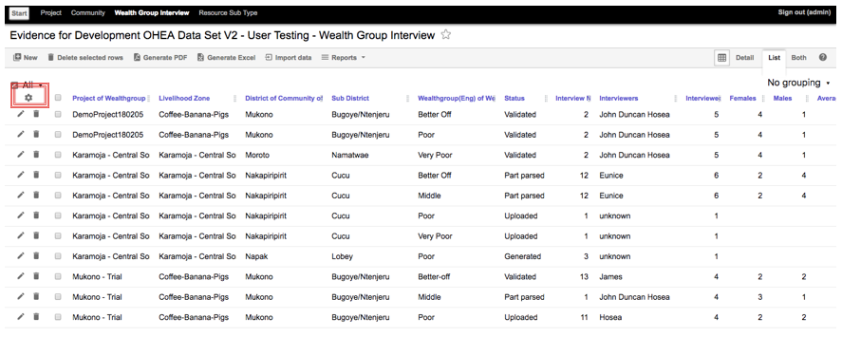

Then you will see the various tools you have.

Click on the **Filter tool** (a funnel icon)

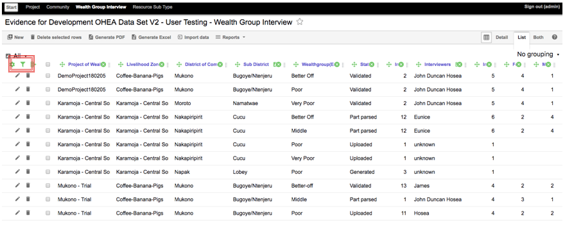

Start to type the name of your project in the filter box

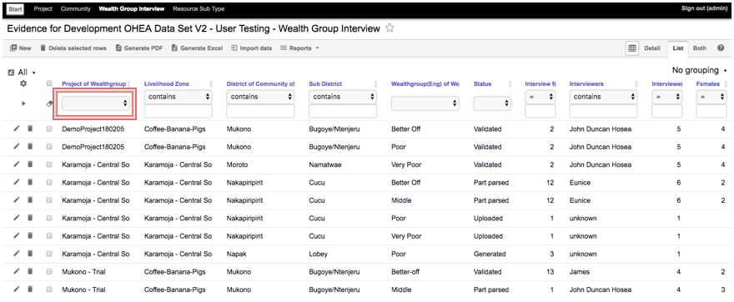

The list will be limited to the matching projects and you will soon get to uniqueness.

When your project is highlighted in the shortening list, hit Enter to select it

You will see your project and all the WGs you have created in it.

Hint: if there are no entries for your project or fewer WGs than you defined, go back to the Communities module and make sure you generated a template spreadsheet for each WG. Until the spreadsheet has been generated, the WG will not show up in the WG Interview module.

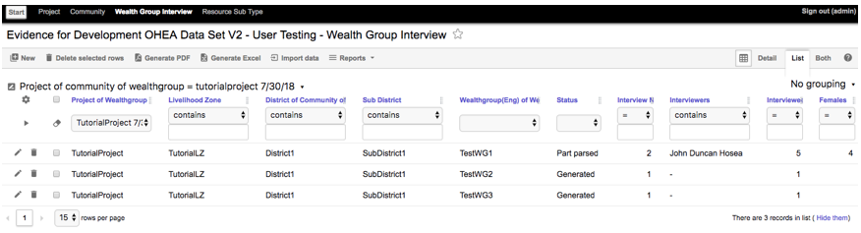

Hint: if you are using the project you created in the first part of this tutorial you will probably only have one WG which will have the status ‘Generated’. That’s all you need for this tutorial.

Click on a (the) WG that has status “Generated”.

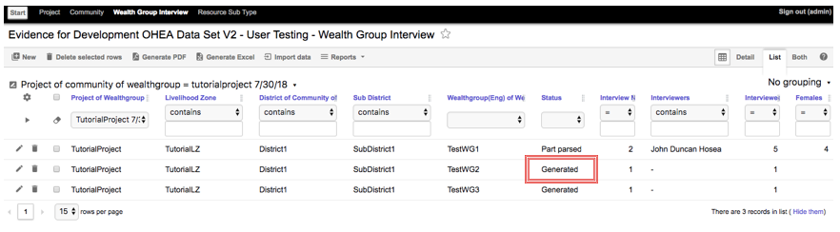

This will display the details of the WG, and you will see a field labelled *Spreadsheet* containing the words the “Select file” and the attach-file icon (paperclip)

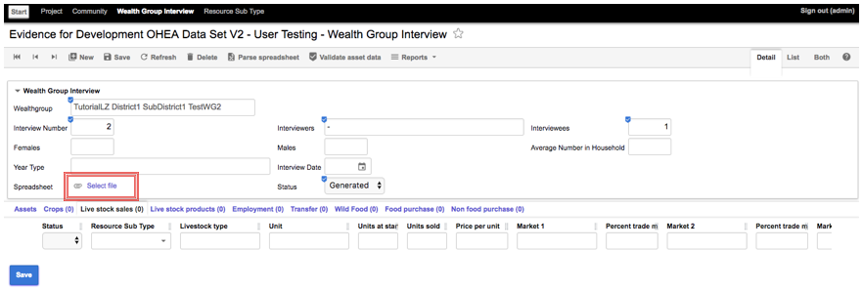

### Parsing the Spreadsheet Data

To upload a spreadsheet, click “Select file” and use the file system dialog to attach your completed WG interview spreadsheet.

Hint: It’s best to use the spreadsheet distributed with this tutorial. All the edits and correction in the next section match the data in that spreadsheet. If you use a different one, the script of the next section will not match what you see in your WG interview.

When the selected file has uploaded, the Spreadsheet field will contain its name and the Status field will change to “Uploaded”.

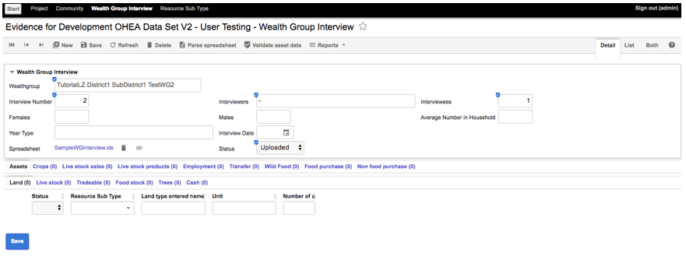

Click **Save**

The spreadsheet loader imports all the data from the Wealth Group interview spreadsheet into a “holding“ space in the database. It is now secured and backed up but is not yet published as part of the project, so all the tabs below the core interview data (Assets, Crops, Livestock Sales, etc.) are blank.

The next step of the process is known as Parsing. Parsing checks that the uploaded spreadsheet is a WG interview spreadsheet in the right format and with the necessary fields completed. At that point the rest of the WG interview record (the tab contents) will be populated.

Click **Parse spreadsheet** in the menu bar to parse the spreadsheet you have uploaded

Click **Save**

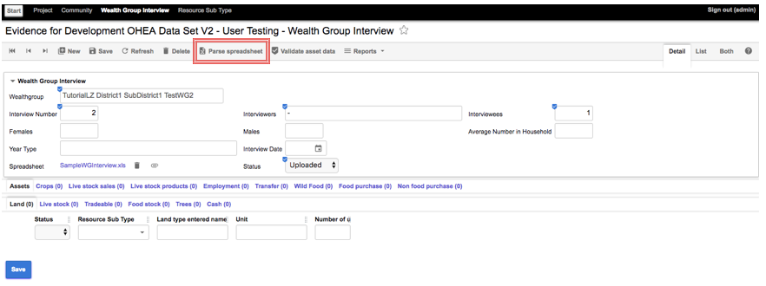

Now you see the Status has been updated to either to “Part parsed” or to “Fully Parsed” and records of the Assets etc have been added to the tabs at the bottom of the screen. Part parsed means that some items in the uploaded spreadsheet are not complete. Usually this means that the resource sub type (the specific Crop, Wild Food or whatever) that has been entered does not match any entry in the database.

Hint: If the Status is “Fully parsed” it means there were no problems in the uploaded spreadsheet. The sample WG interview spreadsheet available with this tutorial does have some anomalies – so you can learn the process of correcting them.

Hint: next to the name of each tab (Crops, Employment, etc) you will see a number in brackets. That is a count of the number of records on that tab. It will help you identify which tabs are blank (e.g. Assets – Trees in the tutorial example). You don’t have to worry about them.

It is vital to match food types with the database because that is where the calorific value of all the food types are stored. And without that information it is not possible to calculate the food access of the WG.

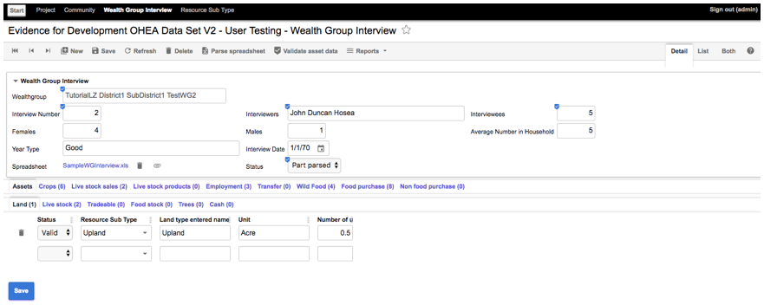

You will have to correct these before you can Validate the whole spreadsheet. So, we need to look at the interview data in more detail.

### Correcting & Completing the Uploaded Spreadsheet Data

The *Assets – Land* tab is displayed, and the *Land type Entered Name* is “Upland”; the Resource *Sub type* is also “Upland”. This means that the value entered in the spreadsheet matches a value in the database for valid Land types. So, the parse for this item has succeeded.

Hint: If the Land Assets tab is not displayed, click on the **Assets** tab, then on the **Land** sub-tab to display it

Click through the other Asset sub-tabs (**Live stock**, **Tradable**, **Food Stock**, **Trees** & **Cash**).

There are either no entries (as in the spreadsheet), or valid entries that have parsed successfully.

Click on the **Crops** tab

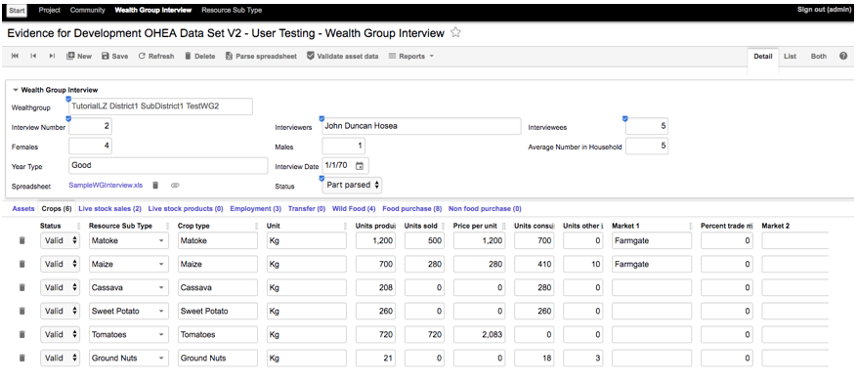

All the entries here are also valid.

Click on the **Live stock Sales** tab

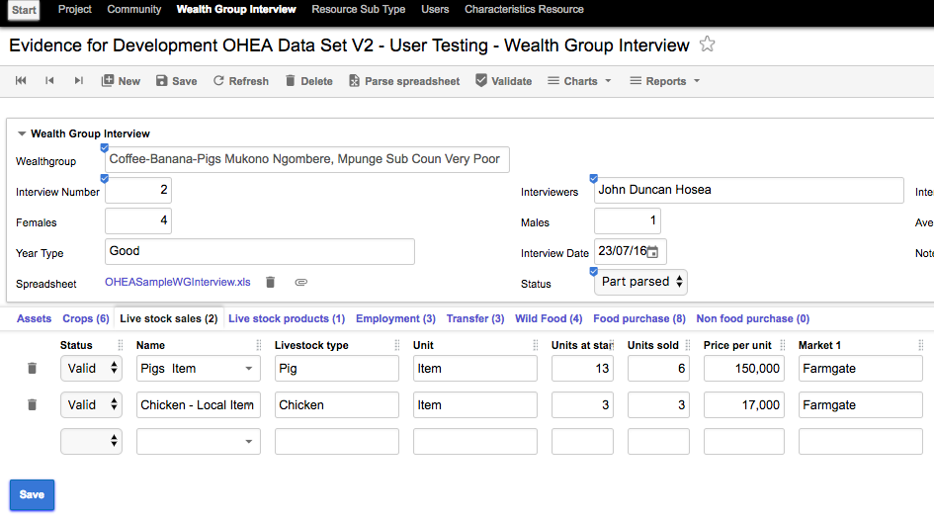The entry for *Livestock type* “Pig” has matched “Pigs” in the database. The Parsing software can matchup some minor differences, such as simple plurals like this.

Click on the **Live stock Products** tab.

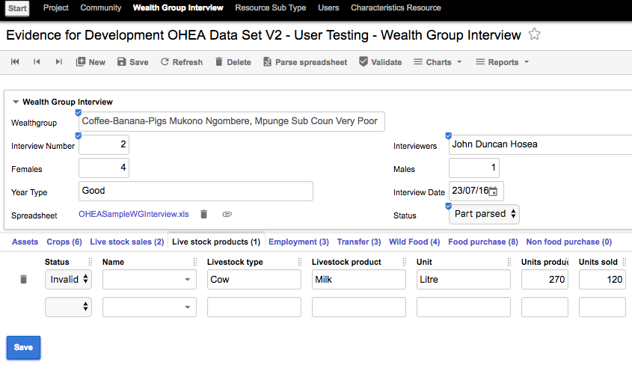

Click on the **Name** drop-down for Cow Milk

Select “Cow’s Milk Litre”

Select **Valid** in the Status list

Click **Save**

The Parsing software can still miss some matches that are obvious to a human.

Click on the **Employment** tab.

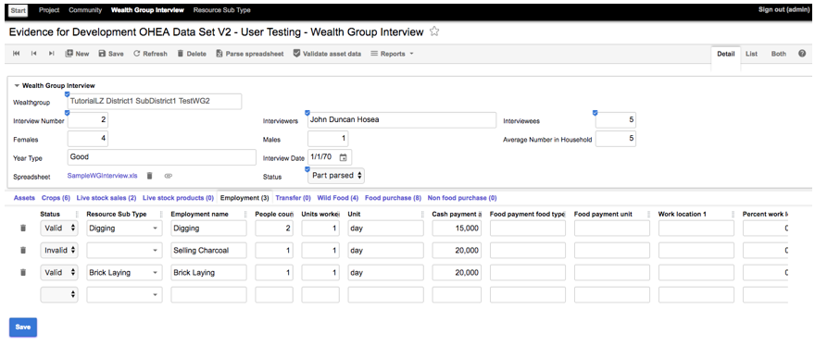

Note the Employment Name “Selling Charcoal” has not been matched in the database.

Click on the **Name** drop-down and select “Petty Trade” as the appropriate match.

Then click on the **Status** list field and select **Valid**

Click **Save**

Next, we will review the Transfers data

Click on the Transfers tab

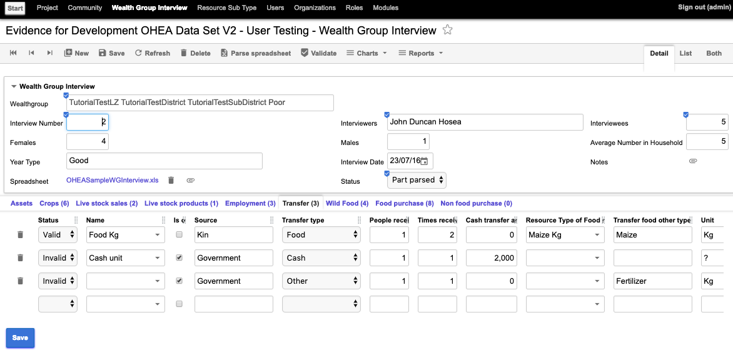

Here we see that the Food transfer has been accepted. The Cash transfer has been matched, but not accepted as valid, because the unit in the spreadsheet was “?”. The Other transfer, of Fertilizer, has not been matched. Currently “Other” transfers have to be matched after upload.

Click on the **Status** list field for the Cash transfer and select **Valid**.

Click on the **Name** drop-down for the Other transfer and select “Fertilizer”.

Click on the **Status** list field for the Cash transfer and select **Valid**.

Click **Save**

We can see from the line counts that there are Wild Foods.

Click on the **Wild Food** Tab

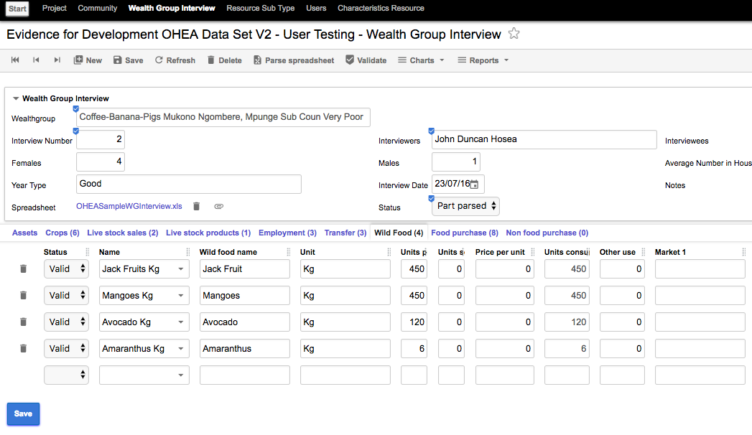

Note that again the plural has been matched. Sometimes there are commonly used synonyms for example “Paraffin” and “Kerosene” or “Matooke” and Matoke” It is possible to set up multiple synonyms for resources in OHEA, so that these will also be automatically matched, but that is beyond the scope of this tutorial.

Click on the **Food Purchase** tab.

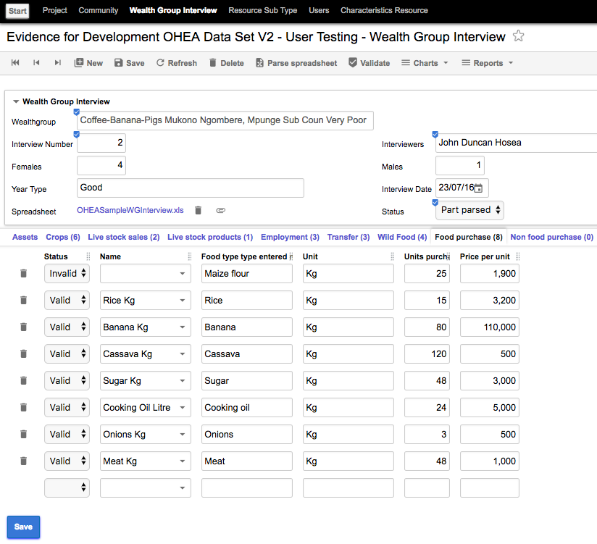

On the **Food Purchase** tab select “Maize” for “Maize Flour.

Click on the **Status** list field for Maize and select **Valid**.

Click **Save.**

### Validating the WG Interview Data

Normally before validating you would check through each tab to make sure everything else is valid. In this tutorial, you have already made all the necessary corrections.

Validation re-checks each item in the spreadsheet to the reference values in the database and it will fail if you have not corrected all the anomalies identified in the Parse.

In this dataset there were some problems that were just alternative spellings. As noted above, synonyms can be set up in the database. Where that has been done an item will parse automatically with any of the valid synonyms without user intervention. If you have not fully corrected all items outstanding from the parsed stage, the Validate operation will fail, with a message or messages indicating where you still have work to do. If that occurs, just return to the tabs in question and complete the edits.

Hint: remember to set the status to “Valid” when you have corrected the Resource name in a record. And click Save before invoking Validate.

Click **Validate**

At this point you have a valid WG interview record. Typically, there will be a number of these to complete for a Community. When these are all complete, you can proceed to view the standard reports for the Community.

### Summary

In this section we have loaded, corrected and validated the results of a Wealth Group interview. In a real study there would be multiple WG interviews, in multiple villages. But they would all follow the same pattern you have seen in this tutorial.

Hint: Only validated WGs will show up in reports. So, if you have not validated all the WGs in a community, the report will only show the validated ones. If there are no Validated WGs in the community, the report will be blank.

# Community Reports

### Viewing core HEA Charts

Open HEA produces a number of standard reports for a community, displaying totals for a typical household and also the ‘per head’ equivalents. Since household sizes can differ significantly between WGs, a normalised view (per person) can often provide a better comparison.

The reports, which are in the form of charts are available in the Charts drop-down menu from the detail view of any WG interview record.

To first confirm that all the WG interviews for a Community have been validated invoke the List view of the WG Interview module.

If you have just completed the validation of a WG interview, click **List** in the top right of the screen.

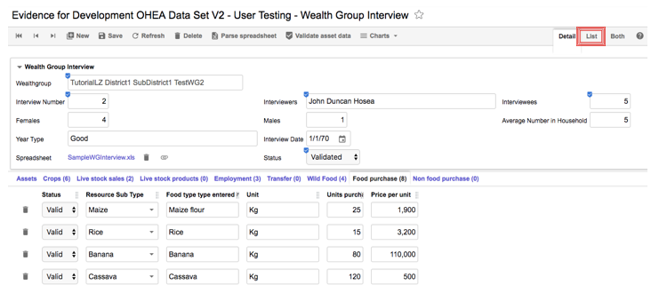

In the list view, you will be able to see the Status of all the WG Interviews. They should all be “Validated”

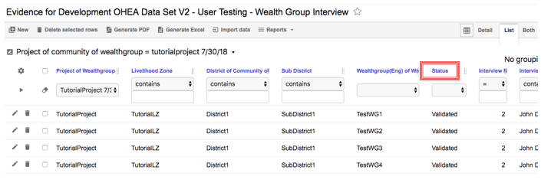

Click any of the Validated WGs to view its detail record

Click **Charts** in the menu bar

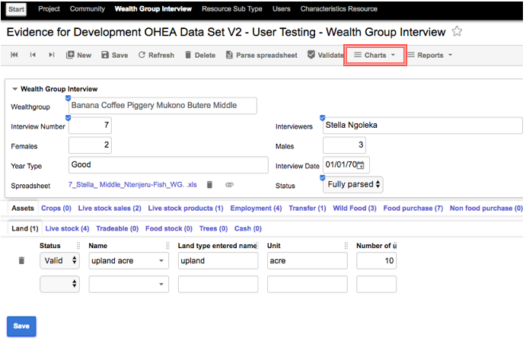

You will see a list of the available charts:

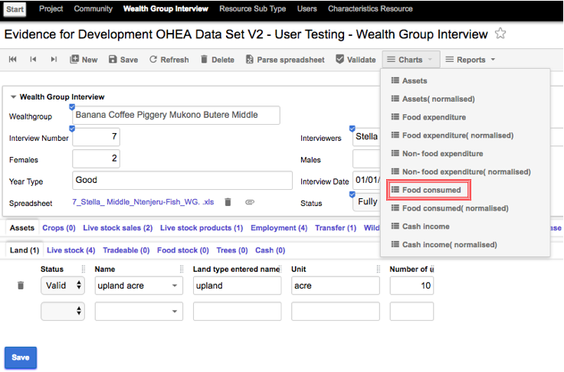

Click “Food Consumed” to run the report

Hint: if you have just run the tutorial on a single WG you will just see a single stack of values, those for the WG you have entered.

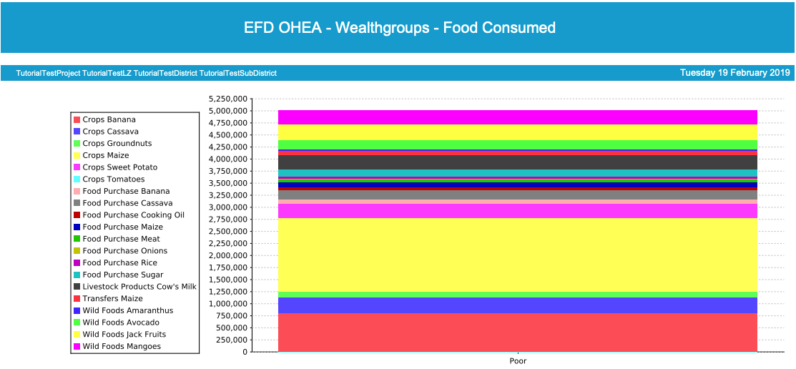

### Some examples of Wealth Group Charts

The other charts show other aspects of the WG’s livelihood. A real-world example, not just a tutorial, will have a richer data set, with multiple WGs’ data.

The example below shows cash income for a community where data for 3 WGs has been entered.

It is displayed as income per person (“Normalised”) for the average size of a household in each WG, and it includes income from all sources: Crops sold, Employment, Livestock Sales & Livestock Product sales.

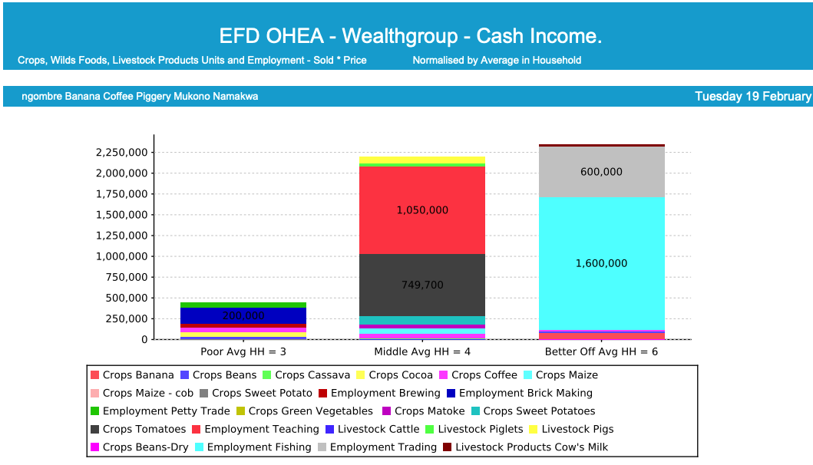

Hint: The report will run in a new browser tab or window – depending on your browser preference settings

This next example shows food expenditure for a Community where only 2 WGs’ data has been entered.

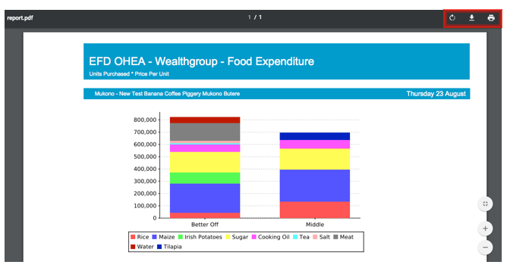

The report produces, and displays its results as a .pdf file, which you can print or download using the controls in the top right corner of the report

All the available charts have 2 variants. One reports the data for a WG and its counterpart reports the same data normalised for the number of people in a household in that WG.

Next to the Charts menu. There is another menu item “Reports”.

This allows you to export all the data for a WG into a spreadsheet for further analysis, modelling and charting, if you need it.

### Charts & Reports

The core charts in OHEA serve two purposes, firstly to allow a team to “sanity check” the data. It is often easy to see mistakes in data collection – for example a huge disparity between WGs might have been caused by an extra ”0” multiplying some resource by 10.

The second purpose is to provide basic reporting form the project.

The data-export reports just provide Excel spreadsheets with raw data from the project for further analysis because HEA projects are likely to have some custom requirements that the core charts do not meet. Analysing the raw data in Excel is beyond the scope of this tutorial.

You have now completed the OHEA core functionality tutorial.

# Summary

The software you have been using is the core HEA Livelihoods module of IDAPs. You have recorded the data from a Livelihood Zone baseline survey. This provides the data that decision makers and researchers need to understand how the people in this LZ live.

Livelihood data is critical for quantitively measuring the impacts of policies, markets, climate and any other external factors on the lives of people affected.

# Appendix A – Acronyms and Abbreviations

IDAPS Integrated Database for African Policymakers

OHEA Open Household Economy Approach

HEA Household Economy Approach

LZ Livelihood Zone

WG Wealth Group

EfD Evidence for Development